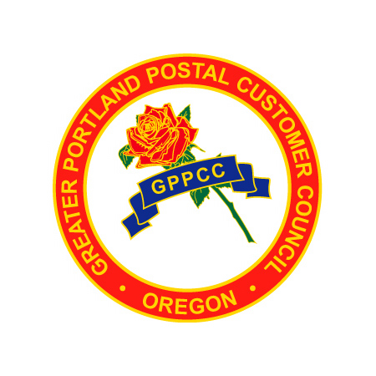The Greater Portland PCC is made up of an extraordinary group of volunteers from our mailing community. Being part of the GPPCC Board is rewarding both personally and professionally. The Board guides the direction of our award winning programs and creates new offerings for our mailing community. If you are interested in joining the Board, we welcome your commitment, support and participation.
GPPCC Officer and Board Member Nomination Form
2014
Please complete this self nomination form and email it to katie.mandzij@pacificorp.com by November 15, 2013.
Officer Nominations (Please indicate first/last name and company affiliation)
Officers must be present for the majority of the monthly meetings and Officer calls. Please consider all positions open for nomination.

Industry Vice-Chair – provides direct support to the Industry Co-Chair: __ _________________________________________________________________________________________________
Treasurer – tracks and manages all expenses, funds and related bank transactions: ___ ________________________________________________________________________________________________
Secretary – takes minutes at the monthly board meeting; distributes: ___ ________________________________________________________________________________________________
Communication Chair – facilitates and coordinates communication activities and the committee members: __ _______________________________________________________________________
Education Chair - facilitates and coordinates education activities and the committee members: ___ ___________________________________________________________________________________
Membership Chair - facilitates and coordinates membership activities and the committee members: ___ ___________________________________________________________________________________

Board Nomination: (Please indicate first/last name and company affiliation)
Board members actively participate in committees and are encouraged to attend monthly meetings.

Board Member: ___ ___________________________________________________________________________
Thank you for your support and participation in the award winning
Greater Portland Postal Customer Council
www.gppcc.com

